1. **Agenda**:
   1. Publishing the very first message from Java App to the Queue Demo.
2. 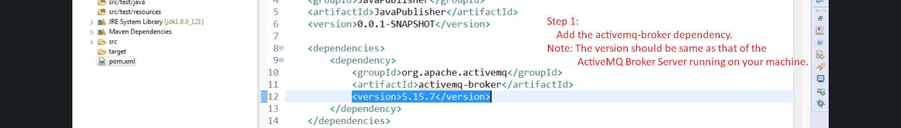
3. Let’s write code to connect with ActiveMQ Server and publish a message to a queue.  
   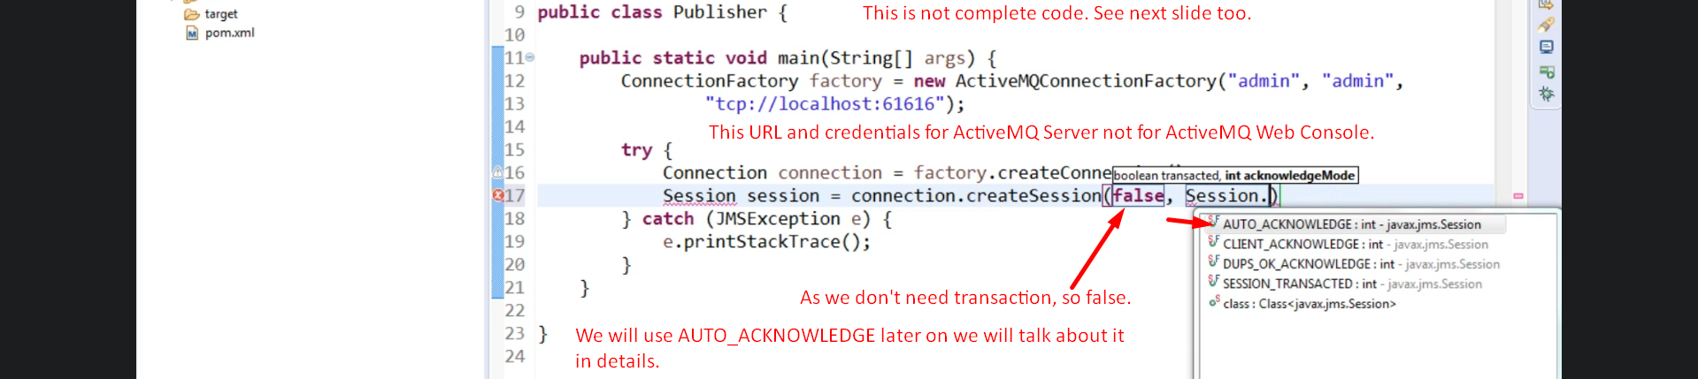  
   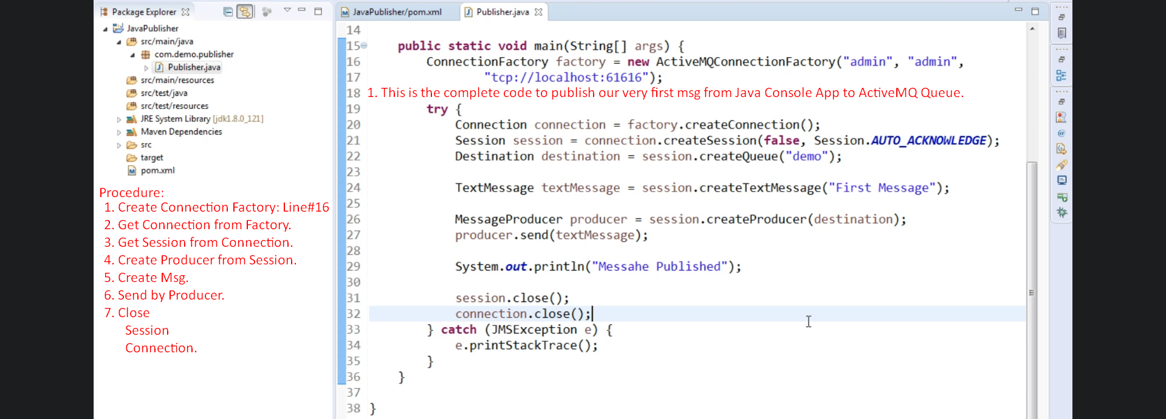
4. Graphical user interface

   Description automatically generated with medium confidence
5. How to see msg in the queue.  
     
   